April 20, 2026

Click or tap here to enter text.
Click or tap here to enter text.

To Whom it May Concern,

The International Association of Movers (IAM) is pleased to confirm that Click or tap here to enter text. is invited to attend the 64th IAM Annual Meeting & Expo, taking place October 21–24, 2026, at the Manchester Grand Hyatt in San Diego, California, USA.

The IAM Annual Meeting & Expo is the moving industry’s premier global event, bringing together more than 1,800 professionals from over 100 countries. The conference provides a platform for professional movers and industry suppliers to network, participate in educational sessions, and collaborate with peers across the international moving community.

Additional information about the event can be found at: https://iammeetings.com/

Click or tap here to enter text.’s participation is strictly for professional and business development purposes related to the conference. We respectfully request that you grant the appropriate visa to attend this international industry conference.

Should you require any additional information, please do not hesitate to contact us.

Thank you for your consideration.

Sincerely,

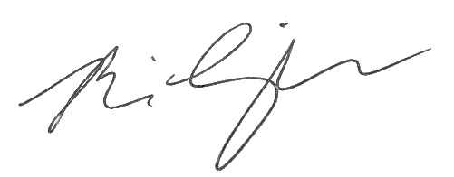
Brian Limperopulos, CAE
President
International Association of Movers

