April 10, 2024

Click or tap here to enter text.
Click or tap here to enter text.

Dear Click or tap here to enter text.,

This is to extend an official invitation for you to attend and participate in the 62nd Annual Meeting and Exposition of the International Association of Movers to be held October 14-17, 2024 at The Cosmopolitan of Las Vegas in Las Vegas, NV.

The international transportation of household goods and personal effects are the main concerns that will be addressed. Since your company is a registered member of this Association, your experience in this field will allow you to make a significant contribution to this meeting, where representatives from the United States and 170 other countries will be present.

It is our sincere wish that you can join us in Las Vegas.

Sincerely,

International Association of Movers

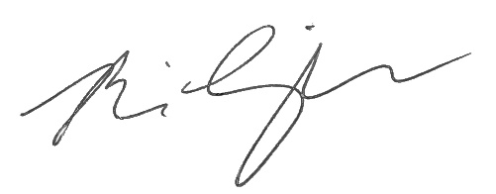
Brian Limperopulos, CAE
President
International Association of Movers

